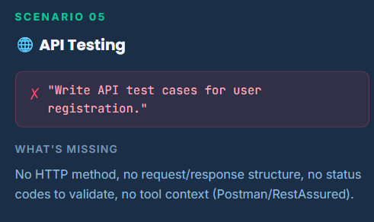

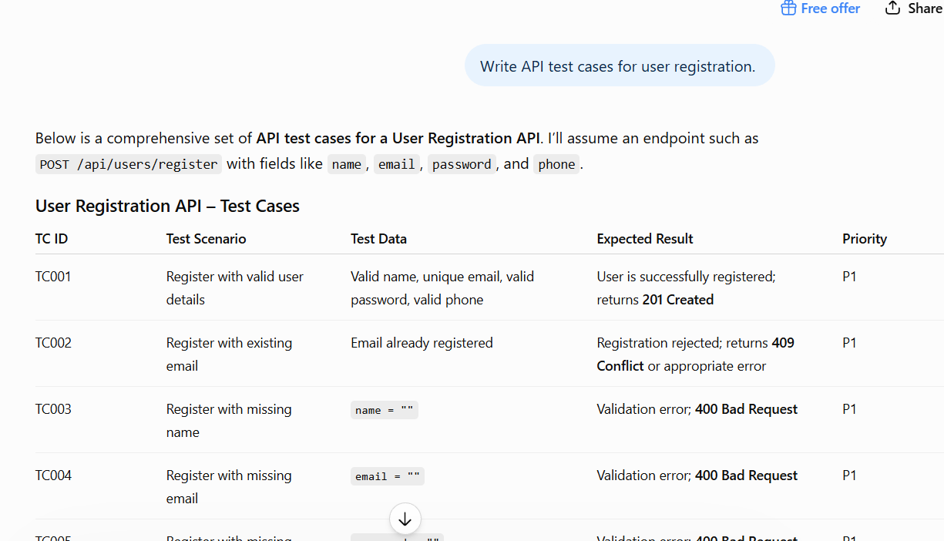

Below is a comprehensive set of API test cases for a User Registration API. I’ll assume an endpoint such as POST /api/users/register with fields like name, email, password, and phone.

User Registration API – Test Cases
TC ID | Test Scenario | Test Data | Expected Result | Priority
TC001 | Register with valid user details | Valid name, unique email, valid password, valid phone | User is successfully registered; returns 201 Created | P1
TC002 | Register with existing email | Email already registered | Registration rejected; returns 409 Conflict or appropriate error | P1
TC003 | Register with missing name | name = "" | Validation error; 400 Bad Request | P1
TC004 | Register with missing email | email = "" | Validation error; 400 Bad Request | P1
TC005 | Register with missing password | password = "" | Validation error; 400 Bad Request | P1
TC006 | Register with missing phone | phone = "" | Validation error if phone is mandatory | P1
TC007 | Invalid email format | abc.com | Validation error; user not created | P1
TC008 | Email without domain | user@ | Validation error | P1
TC009 | Email with spaces | user @gmail.com | Validation error | P2
TC010 | Password below minimum length | Ab1@ | Password validation error | P1
TC011 | Password without uppercase character | password@123 | Validation error if uppercase required | P2
TC012 | Password without special character | Password123 | Validation error if special character required | P2
TC013 | Password without number | Password@ | Validation error if number required | P2
TC014 | Password containing only spaces | " " | Validation error | P1
TC015 | Name containing numbers | John123 | Rejected if numeric characters are not allowed | P2
TC016 | Name containing special characters | John@#$ | Validation error if special characters aren't allowed | P2
TC017 | Phone number with valid format | 9876543210 | Registration succeeds | P1
TC018 | Phone number with fewer digits | 987654321 | Validation error | P1
TC019 | Phone number with more digits | 98765432101 | Validation error | P2
TC020 | Phone containing alphabets | 98765ABCDE | Validation error | P1
TC021 | All mandatory fields missing | {} | 400 Bad Request with field-level errors | P1
TC022 | Null values | name:null, email:null, password:null | Validation error | P1
TC023 | Duplicate phone number | Existing phone number | Registration rejected if phone must be unique | P1
TC024 | Leading/trailing spaces | " John " / " user@gmail.com " | API trims input or rejects appropriately | P2
TC025 | Very long name | Name > maximum allowed length | Validation error | P2
TC026 | Very long email | Email > maximum allowed length | Validation error | P2
TC027 | SQL injection input | ' OR 1=1 -- | Request safely rejected/handled; no DB compromise | P1
TC028 | XSS payload | <script>alert(1)</script> | Input safely handled/encoded/rejected | P1
TC029 | Unsupported HTTP method | GET /api/users/register | 405 Method Not Allowed | P2
TC030 | Missing Content-Type | JSON body without Content-Type | Appropriate 400/415 response | P2
TC031 | Invalid Content-Type | Content-Type: text/plain | 415 Unsupported Media Type | P2
TC032 | Malformed JSON | {name:"John",email:"test"} | 400 Bad Request | P1
TC033 | Extra unexpected fields | Add "role":"admin" | Extra fields ignored/rejected; user cannot self-assign privileged role | P1
TC034 | Password returned in response | Valid registration | Password must not be returned in response | P1
TC035 | Verify response schema | Valid registration | Response contains expected fields and correct data types | P1
TC036 | Verify database record | Valid registration | User is correctly persisted in DB | P1
TC037 | Verify password storage | Valid registration | Password is hashed; plaintext password is never stored | P1
TC038 | Verify authentication/token | Valid registration | Token is returned only if API specification requires it | P2
TC039 | Concurrent registration with same email | Two requests with same email simultaneously | Only one user is created; duplicate request fails | P1
TC040 | Server/database unavailable | Valid registration | Graceful 5xx error; no partial/corrupt user record | P1

Example valid request
{
"name": "John Doe",
"email": "john.doe@test.com",
"password": "Test@12345",
"phone": "9876543210"
}

Expected success response
{
"id": 1001,
"name": "John Doe",
"email": "john.doe@test.com",
"message": "User registered successfully"
}
Important API validations: verify status code, response body/schema, headers, response time, database persistence, duplicate handling, authentication/security, and that sensitive data such as passwords is never exposed.

Strong Prompt:

Instructions:
- Generate API Test cases for user registration
- [critical] Generate positive and negative Testcases
- [Priority] Generate only 10 testcases
- [High Priority] Generate p1 and p2 testcases
- Write testscript and validate status code using Selenium, BDD, RestAssured, Java
Context:
Generate test cases for healthcare applications.
Test in postman and Rest Assured using java
Examples:
TC_ID|Description|Priority|Preconditions|Method|Steps|Testdata|Expected Output|request/response structure|Comments|raised by|Review score|Reviewed By
Persona:
Act as a Senior Engineer to Generate/Design testcase
Act as a Test lead to review the testcase
Output Format:
Generate test cases in table and downloadable excel format
Generate the report in html
Tone:
Professional and concise

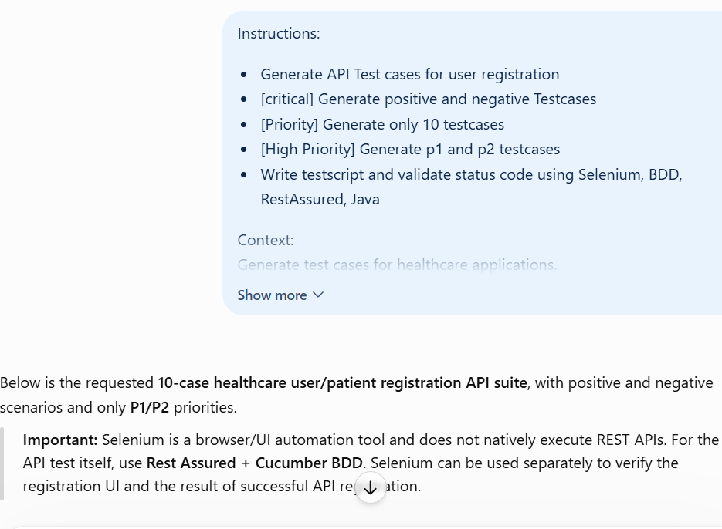

API Test Cases
TC_ID | Description | Priority | Preconditions | Method | Steps | Testdata | Expected Output | Request/Response Structure | Comments | Raised By | Review Score | Reviewed By
TC_REG_001 | Register patient with valid mandatory details | P1 | API available; email/phone unique | POST | Send valid JSON; validate status and schema | Valid name, unique email, strong password, DOB, phone | 201 Created; patient ID returned; password not exposed | JSON request → patientId/name/email/message response | Positive happy path | Senior Engineer | 5/5 | Test Lead
TC_REG_002 | Reject registration when email is missing | P1 | API available | POST | Send request without email; validate status/error | Email omitted; other fields valid | 400 Bad Request; email validation error | JSON without email → validation error | Negative validation | Senior Engineer | 5/5 | Test Lead
TC_REG_003 | Reject invalid email format | P1 | API available | POST | Send malformed email; validate status | john@ | 400 Bad Request; invalid email error | Invalid email → validation error | Negative validation | Senior Engineer | 5/5 | Test Lead
TC_REG_004 | Reject duplicate email | P1 | Patient already exists | POST | Submit existing email; validate response and DB | Existing patient email | 409 Conflict or documented duplicate error | Existing email → duplicate error | Data integrity | Senior Engineer | 5/5 | Test Lead
TC_REG_005 | Reject weak password | P2 | Password policy configured | POST | Submit weak password; validate status | 12345 | 400 Bad Request; password policy error | Weak password → validation error | Security validation | Senior Engineer | 5/5 | Test Lead
TC_REG_006 | Reject invalid phone number | P2 | API available | POST | Submit invalid phone; validate status | 98ABC123 | 400 Bad Request; phone validation error | Invalid phone → validation error | Negative validation | Senior Engineer | 5/5 | Test Lead
TC_REG_007 | Reject malformed JSON | P2 | API available | POST | Send malformed JSON with JSON content type | Invalid JSON syntax | 400 Bad Request; structured error | Malformed JSON → error response | API contract | Senior Engineer | 5/5 | Test Lead
TC_REG_008 | Reject unsupported content type | P2 | API available | POST | Send payload using unsupported content type | Content-Type: text/plain | 415 Unsupported Media Type or documented response | text/plain request → media-type error | API contract | Senior Engineer | 5/5 | Test Lead
TC_REG_009 | Reject unauthorized request when authentication is required | P1 | Endpoint requires authentication | POST | Send request without/with invalid token | Missing/invalid Bearer token | 401 Unauthorized; no patient created | Invalid auth → authentication error | Access control | Senior Engineer | 5/5 | Test Lead
TC_REG_010 | Prevent duplicate patient during concurrent registration | P1 | Unique email available | POST | Send two simultaneous requests with same email; validate both | Same unique email | Only one patient created; other request gets conflict/duplicate response | Two identical requests → one success + one conflict | Concurrency/data integrity | Senior Engineer | 5/5 | Test Lead

Cucumber BDD + Rest Assured Java

Feature file
Feature: Healthcare Patient Registration API

@P1 @Positive @Registration
Scenario: Register patient with valid details
Given the registration API is available
When I send a POST request with valid patient details
Then the response status code should be 201
And the response should contain a patient ID

@P1 @Negative @Registration
Scenario: Reject registration when email is missing
Given the registration API is available
When I send a POST request without email
Then the response status code should be 400

@P1 @Negative @Registration
Scenario: Reject registration with invalid email
Given the registration API is available
When I send a POST request with invalid email
Then the response status code should be 400

@P1 @Negative @Registration
Scenario: Reject duplicate patient email
Given a patient already exists with the email
When I register another patient with the same email
Then the response status code should be 409

@P2 @Negative @Registration
Scenario: Reject weak password
Given the registration API is available
When I register a patient with a weak password
Then the response status code should be 400

Rest Assured Step Definitions
package stepdefinitions;

import io.cucumber.java.en.*;
import io.restassured.response.Response;

import static io.restassured.RestAssured.*;
import static org.hamcrest.Matchers.*;

public class RegistrationSteps {

private Response response;

private final String baseUrl =
"https://healthcare-api.example.com";

@Given("the registration API is available")
public void registrationApiIsAvailable() {
baseURI = baseUrl;
}

@When("I send a POST request with valid patient details")
public void sendValidRegistrationRequest() {

String requestBody = """
{
"name": "John Doe",
"email": "john.unique@test.com",
"password": "Test@12345",
"dob": "1990-05-15",
"phone": "9876543210"
}
""";

response =
given()
.header("Content-Type", "application/json")
.body(requestBody)
.when()
.post("/api/patients/register");
}

@When("I send a POST request without email")
public void sendRequestWithoutEmail() {

String requestBody = """
{
"name": "John Doe",
"password": "Test@12345",
"dob": "1990-05-15",
"phone": "9876543210"
}
""";

response =
given()
.header("Content-Type", "application/json")
.body(requestBody)
.when()
.post("/api/patients/register");
}

@When("I send a POST request with invalid email")
public void sendRequestWithInvalidEmail() {

String requestBody = """
{
"name": "John Doe",
"email": "john@",
"password": "Test@12345",
"dob": "1990-05-15",
"phone": "9876543210"
}
""";

response =
given()
.header("Content-Type", "application/json")
.body(requestBody)
.when()
.post("/api/patients/register");
}

@Then("the response status code should be {int}")
public void validateStatusCode(int expectedStatusCode) {

response.then()
.statusCode(expectedStatusCode);
}

@Then("the response should contain a patient ID")
public void validatePatientId() {

response.then()
.body("patientId", notNullValue());
}
}

Selenium + API combined approach
For a healthcare application, the framework can be structured as:
HealthcareAutomation
│
├── src/test/java
│ ├── runners
│ │ └── TestRunner.java
│ │
│ ├── stepdefinitions
│ │ ├── RegistrationSteps.java
│ │ └── RegistrationUISteps.java
│ │
│ ├── pages
│ │ └── RegistrationPage.java
│ │
│ └── utils
│ └── TestDataReader.java
│
├── src/test/resources
│ └── features
│ └── Registration.feature
│
└── pom.xml
Rest Assured → API request/response and HTTP status validation
Cucumber → BDD/Gherkin scenarios and tags
Selenium → healthcare registration UI/browser validation
TestNG/JUnit → test execution
Postman → manual/API exploratory validation

